# Computer vision Sheet02 theory answer

**Group members:**

* Parsa Eissazadeh ([s68peiss@uni-bonn.de](mailto:s68peiss@uni-bonn.de), 50234732)
* Pranav Yadav ([s52pyada@uni-bonn.de](mailto:s52pyada@uni-bonn.de) 50327698)

## Q1

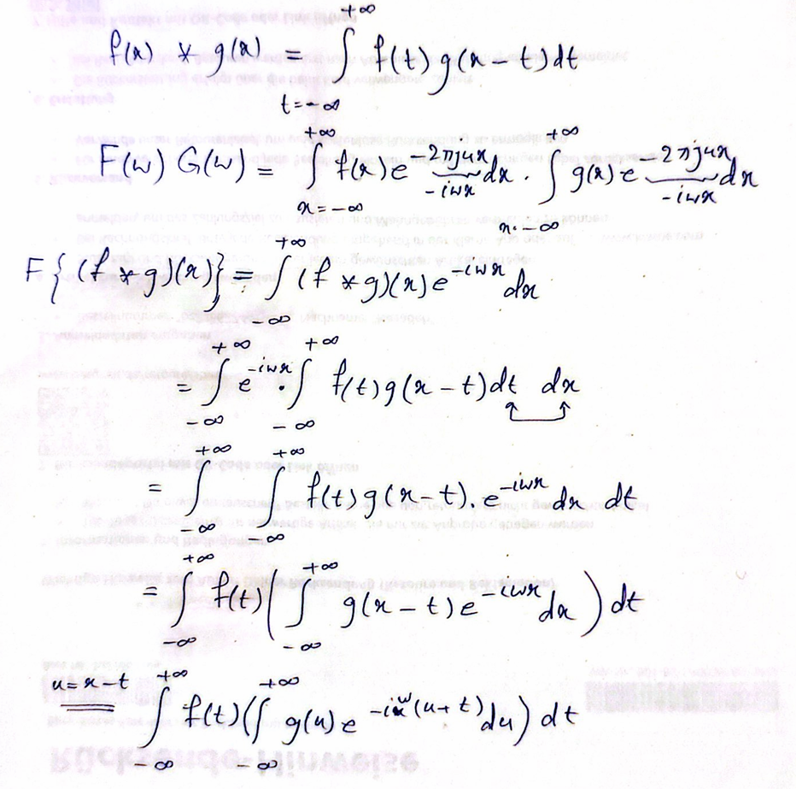

s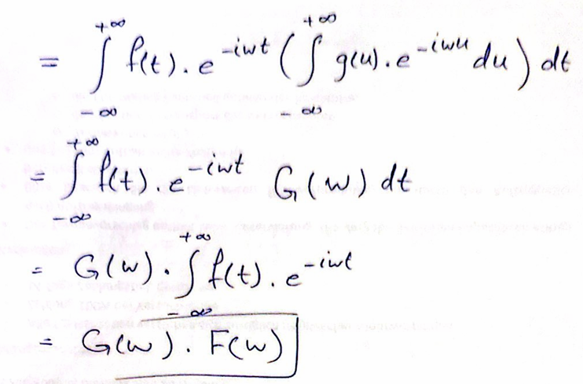

**You can see the outputs of Q3 and Q5 codes in the “output” directory.**